**IMPORTANCE OF HAVING A SCHEMA IN DATASETS**

**Table of Contents**

1. Introduction  
   1.1 Overview of Data Types (Structured)  
   1.2 Importance of Schema in Data Management
2. Dataset Analysis  
   2.1 Description of Selected Datasets  
   2.2 Observed Schemas and Attributes
3. Comparative Analysis  
   3.1 Advantages and Disadvantages of Having a Schema

3.2 Advantages and Disadvantages of Not Having a Schema

3.3 Impact on Data Processing and Analysis

1. Practical Scenarios  
   4.1 Real-World Examples and Use Cases  
   4.2 Visual Aids (Charts, Diagrams, Tables)
2. Conclusion  
   5.1 Summary of Findings  
   5.2 Recommendations Based on Analysis
3. References

**INTRODUCTION**

Structured data refers to any data that is organized in a predefined, consistent format, typically in the form of tables with rows and columns. This type of data is highly organized and easily searchable, making it simple to store, retrieve, and analyze using traditional data management tools.

In data management, a schema serves as the foundation for organizing, structuring, and interpreting data within a dataset. It defines the relationships, constraints, and data types that ensure data is stored and accessed efficiently.

**This project delves** into the significance of schemas in datasets, exploring how well-defined schemas enable the organization of structured data which aims to underscore the pivotal role schemas play in ensuring the efficient management of datasets across various data environments. Ultimately, understanding and designing the right schema can lead to more accurate insights and better data-driven decisions.

**Steps include**:

1. Dataset Analysis.
2. Comparative Analysis
3. Practical Scenario
4. Conclusion
5. References

**STEP 1**

**Dataset Analysis**

**Dataset 1: Simple Structured Dataset**

**Example**: Car Sales Dataset (CSV)

* **Source**: Kaggle - Car Sales Dataset
* **Description**: This dataset contains car sales data with attributes like car model, price, and year of manufacture. The schema is simple and flat, making it easy to process and analyze for tasks like price prediction.
* **Schema structure**: This dataset has a relatively simple flat structure with only a few key attributes.

|  |  |  |
| --- | --- | --- |
| **Column Name** | **Data Type**  **(Python)** | **Description** |
| Model | String | Car model name |
| Year | Integer | Year of manufacture |
| Price | Float | Price of the car |
| Mileage | Integer | Mileage in km |
| Brand | String | Brand of the car |
| Colour | string | Colour of the car |

* **Analysis**: This dataset is easy to analyze with simple regression models or basic data visualization. It's ideal for predicting car prices based on mileage, year, and other features.

**Dataset 2: Moderately Complex Structured Dataset**

**Example**: House Prices: Advanced Regression Techniques (CSV)

* **Source**: Kaggle - House Prices: Advanced Regression Techniques
* **Description**: This dataset contains information about house sales in King County, USA, with various attributes like square footage, year built, and neighborhood. It is used for regression tasks to predict house prices based on the features provided.
* **Schema structure**: This dataset has more complexity with a larger number of features and some categorical attributes that require encoding.

|  |  |  |
| --- | --- | --- |
| **Column Name** | **Data Type**  **(Python)** | **Description** |
| Id | Integer | Unique identifier for each house sale |
| MSSubClass | Integer | Type of dwelling (e.g., 1-story, 2-story) |
| MSZoning | String | The general zoning classification |
| LotFrontage | Float | Linear feet of street connected to property |
| LotArea | Integer | Lot size in square feet |
| Street | String | Type of street access (Gravel, Paved) |
| Alley | String | Type of alley access (Gravel, Paved) |
| BldgType | String | Type of building (1Fam, 2fmCon, etc.) |
| HouseStyle | String | style of dwelling (2Story, 1Story, etc.) |
| YearBuilt | Integer | year the house was built |
| OverallQual | Integer | Overall material and finish quality |
| SalePrice | integer | Sale price of the house |

* **Analysis**: The House Prices dataset is more complex than the Cr sales dataset, as it includes a mix of continuous, categorical, and ordinal data. This dataset is ideal for regression modeling but requires more preprocessing (e.g., handling missing data, encoding categorical features) and feature engineering.

**Dataset 3: Highly Complex Structured Dataset**

**Example**: Open Flights Airline Network Data (SQL)

* **Source**: Open Flights Database
* **Description**: The Open Flights dataset includes information about airports, airlines, and flight routes worldwide. The data is relational, linking different entities through foreign keys.
* **Schema** **Complexity**: High (Normalized relational schema with multiple tables).
* S**chema Structure:**

There are 3 tables- Airports table, Airlines Table, Routes Table

**Airports Table:**

|  |  |  |
| --- | --- | --- |
| **Column** | **Data type** | **Description** |
| AirportID | Integer | Unique identifier for airport |
| Name | String | Airport Name |
| City | String | City where the airport is located |
| Country | string | country where the airport is located |

**Airlines Table:**

|  |  |  |
| --- | --- | --- |
| **Column** | **Data type** | **Description** |
| AirlineID | Integer | Unique identifier for airline |
| Name | String | Airline Name |
| Country | String | Country where the airline operates |

**Routes Table:**

|  |  |  |
| --- | --- | --- |
| **Column** | **Data type** | **Description** |
| RouteID | Integer | Unique route identifier |
| AirlineID | Integer | Foreign key referencing Airlines Table |
| SourceAirport | Integer | Foreign key referencing Airports Table |
| DestinationAirport | Integer | Foreign key referencing Airports Table |

* **Analysis:** Network analysis of airline routes. Using complex SQL queries to retrieve flight paths, airport connections, and airline operations.

**STEP 2**

**Comparative Analysis**

* **Advantages and disadvantages of having a schema.**

**Advantages:**

* **Data Integrity and Validation**: Ensures that only valid data is entered (e.g., correct data types, mandatory fields).
* **Efficiency in Queries**: Predefined structure speeds up queries and optimizes indexing for quick retrieval.
* **Data Consistency**: Maintains consistent formats and relationships across datasets.
* **Scalability**: Easier to scale and extend data storage, as relationships are clearly defined.

**Disadvantages:**

* **Flexibility**: Can be rigid. Changes to schema (e.g., adding columns or modifying relationships) may require restructuring and can be disruptive.
* **Overhead in Design**: The process of designing a schema can be time-consuming, especially for complex datasets.
* **Complexity in Maintenance**: Larger, more complex schemas can become hard to maintain over time, particularly with evolving business requirements.
* **Advantages and disadvantages of Not Having a Schema.**

**Advantages:**

* **Flexibility**: Schema-less or semi-structured data (e.g., NoSQL databases like MongoDB) can adapt to changing data without requiring schema redesign.
* **Faster Development**: Can speed up the initial development process by not needing a predefined schema.
* **Handling Unstructured Data**: Ideal for data that doesn't fit neatly into a table format (e.g., JSON, XML).

**Disadvantages:**

* **Data Integrity Issues**: Without a schema, ensuring data consistency becomes harder, which may lead to errors or incorrect data.
* **Inefficient Queries**: Lack of predefined structure can make data retrieval slow and cumbersome, especially for large datasets.
* **Data Redundancy and Inconsistency**: More prone to duplicate data and lack of standardization, making it harder to maintain relationships between data points.
* **Impact on data processing, storage, retrieval, and analysis.**

A well-defined schema affects how data is ingested, transformed, validated, and stored. Here’s how different schema structures positively and negatively influence processing:

|  |  |  |
| --- | --- | --- |
| **Process** | **Positive Impact on process** | **Negative impact on process** |
| **Data Processing** | * Ensures Data Integrity and Consistency * Optimizes Query Processing * Enables Efficient Data Transformation (ETL) * Improves Storage Efficiency | * Slower Data Ingestion * Schema Evolution Challenges * Complex Query Execution in Highly Normalized Schemas |
| **Data Storage** | * Efficient Storage Management. * Partitioning and Sharding. * Compression and Indexing | * High Storage Overhead * Preallocated Space Wastage * Schema Evolution Complexity |
| **Data Retrieval** | * Structured and Predictable Queries * Data Consistency in Retrieval * Fast Query Performance. | * Schema Rigidity Limits Flexibility. * Performance Overhead. * Complex Queries in Normalized Schemas |
| **Data Analysis** | * Facilitates Accurate and Predictable Reporting. * Supports Complex Aggregations and Advanced Queries * Enhances Data Security and Governance * Enables Faster Data Warehousing and OLAP Queries | * Performance Bottlenecks in Large Datasets. * Less Flexibility for Exploratory Analysis. * Not Suitable for Unstructured or Semi-Structured Data |

**STEP 3**

**Practical Scenarios**

**Real-world examples and use cases**

* **Employee Management System (Schema**): HR departments need a schema to store employee data, salaries, and performance metrics. This enables efficient payroll processing, tracking performance, and maintaining employee records for future queries.
* **E-commerce Database (Schema):** The e-commerce site needs a well-defined schema to store customer information, products, and transactions. Having a schema ensures that data like payment information, order status, and product catalog can be consistently and efficiently retrieved for reports and analysis**.**

**Visual aids (charts, diagrams, tables).**

* **ER Diagram (Entity Relationship Diagram)**

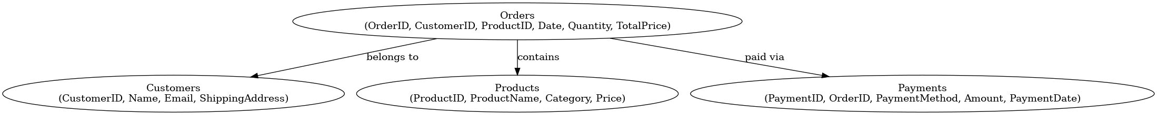

This Entity-Relationship Diagram (ERD) represents the schema of an E-commerce Orders Database.

* **Bar Chart**

**Bar Chart: Schema vs. No Schema**

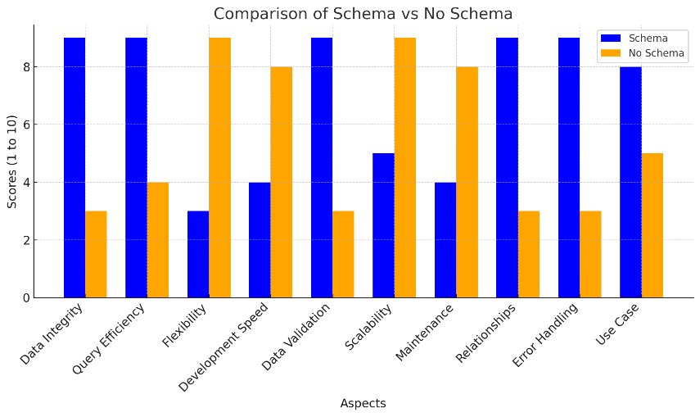

Here is the bar chart comparing Schema vs No Schema based on different aspects. Each bar represents a score (from 1 to 10) for each aspect, with higher scores indicating better performance.

**Conclusion**

**Summary of Findings:**

* According to the first dataset example (Car sales) which uses a simple schema structure, provides straightforward data storage, retrieval, and manipulation, making it accessible for users with limited database expertise. Querying and processing data is generally fast since there are fewer joins or complex relationships and simple schema architecture is ideal for small to medium-sized datasets where ease of use and quick data access are priorities.
* The second dataset House prices follow a moderate schema architecture, balancing simplicity and structure which included multiple related tables or structured attributes, providing a more organized approach to data management while maintaining flexibility.
* In this example, I analyzed a dataset utilizing a complex schema architecture, characterized by multiple interrelated tables, strict constraints, and normalized structures. This schema design ensures data integrity, scalability, and efficiency, making it ideal for large-scale applications and enterprise systems.

**Recommendations:**

* For systems with stable, structured data (e.g., financial databases, employee records), it is crucial to have a schema for efficient data management.
* For rapidly evolving data or systems that require high flexibility (e.g., social media platforms), a schema-less or flexible schema approach (e.g., NoSQL) might be more beneficial.

**References**

* [**https://www.kaggle.com/competitions/house-prices-advanced-regression-techniques**](https://www.kaggle.com/competitions/house-prices-advanced-regression-techniques)
* [**https://www.simplilearn.com/tutorials/sql-tutorial/schema-in-sql**](https://www.simplilearn.com/tutorials/sql-tutorial/schema-in-sql)